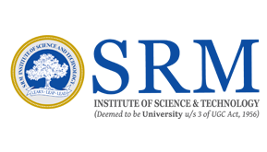

International Conference on Artificial Intelligence and Evolutionary Computations in Engineering Systems
ICAIECES-2019

April 11th - 13 th, 2019

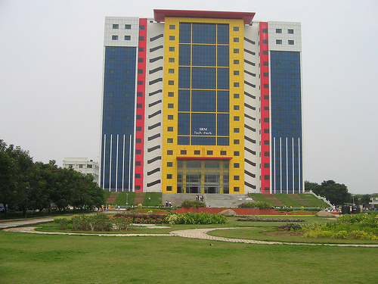

Organized By

Department of Software Engineering
SRM Institute of Science and Technology, Chennai-603203, INDIA.
http://www.icaieces2019.com, http://www.srmuniv.ac.in

About SRM

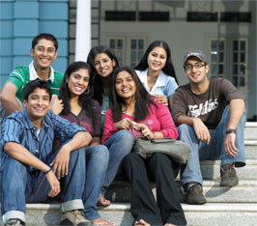
SRM Institute of Science and Technology (SRMIST) is one of the pioneering engineering institutions of INDIA, was established in 1985. It offers a wide range of programs as Undergraduate, Post graduate and Doctoral courses. SRMIST has collaboration with the leading institutions globally to provide a platform and experience international standards in Education and Research to SRM Students & Researchers.

SRM group of institutions are span across India with 4 main campuses and 7 other groups of institution attracting students both from India and Abroad. Academically SRM offers global faculty members, flexible and dynamic curriculum, exciting research and global connections are features that set SRM apart. SRM frontrunners are their Internal and Corporate Advisory Board who play a key role in formulating academic and research after interaction with faculties and students.

SRMIST research covers all major academic disciplines to establish state of the art multi-disciplinary, inter-disciplinary and co-disciplinary research institute in a dynamic, competitive and vibrant environment. SRMIST has key facilities like Nano Technology research Centre, Centre for Environmental Nuclear Research (CERN), Centre for Advanced Concrete Research (CACR), Interdisciplinary Institute of Indian System of Medicine (IIISM), Earthquake Research Cell, Medical Research Centre, Indian Nodal Bioethics Centre of the UNESCO International Chair on Bioethics, Bioengineering, Multidisciplinary Research, Funded and Undergraduate Research. SRM School of Computing has lab infrastructure is supported by Government, Corporate and In-House labs like Big Data Analytics, Cloud Computing, Internet of Things (IoT), Wireless Networking Lab, Brain Computer Interface Lab, PURA and also collaboration with major corporate giants like NOKIA, CISCO, Microsoft and LDRA.

SRMIST creates a platform to students in connecting with many leading companies for Industrial Training, Internship and Placements by crafting a benchmark in the Placement Track. SRM host various students clubs and social relevant activities for the students to plinth their talent in various areas other than the academics.

About Department of Software Engineering
The Software Engineering (SWE) is one of the significant specializations in School of Computing. Software Engineering enhances the students to extend, strengthen the ability to develop and sustain the transformative software systems of tomorrow. The department activities is determined to create Future Leaders and Trend Setters for the next generation. This Department offers a Comprehensive Under Graduate course curriculum that prepares the students to be leaders in software Engineering. Department of Software Engineering started offering UG courses from 2008 onwards. Well qualified and experienced faculties form the backbone of the department. Resource persons from various industries are invited to deliver Class Room Sessions, Industry Based Hands-on Activities, Guest Lectures and Seminars related in the curriculum and software industry trending topics.
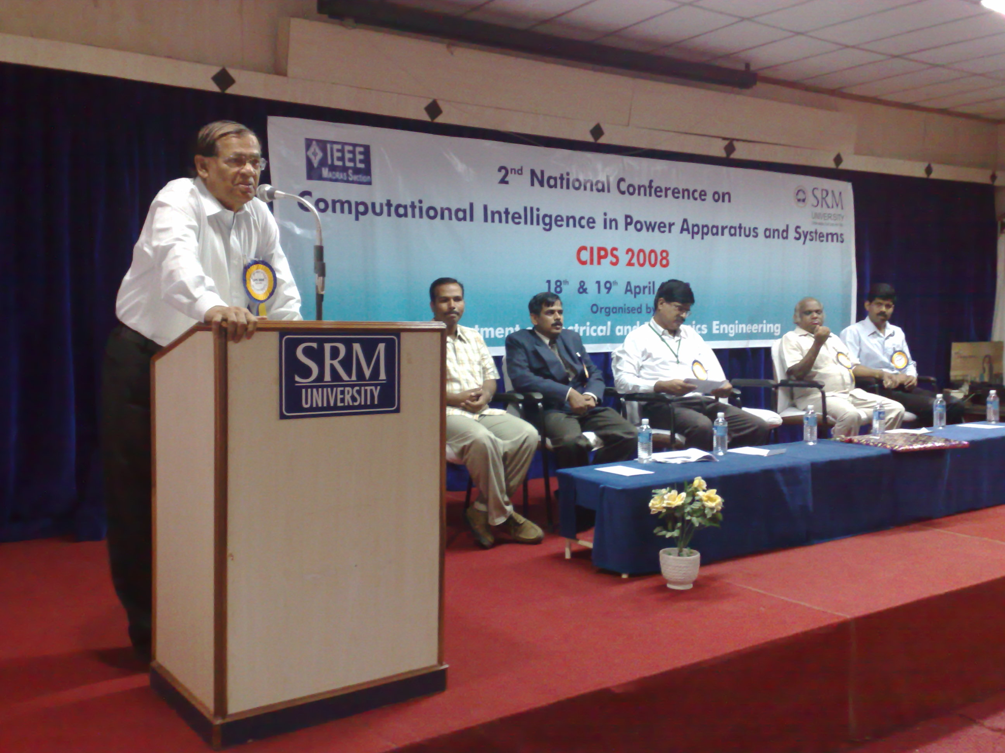

Research & consultancy
The Research Division of Software Engineering Department covers various aspects of Computer Vision, Software Process & Engineering, Network Systems & Services and Computing Technologies. The key player for this conference is the Computer Vision research group working in major research fields of Artificial Intelligence, Big Data Analytics, IoT, Machine & Deep Learning, Image Processing, Augmented Reality and Robotics. The Networking Systems and Services group graft on research areas such as Wireless Sensor Networks, Adhoc Networks, VANET and Security. Computing Technologies group concentrates on Data Mining, Analysis and Prediction, Human Computer Interface, Virtual Reality, Brain Computing, Distributed Computing, Social Media Network, Mobile and Pervasive Computing. There is an active and growing area of research in the field Software Engineering as Measurements, Metric, Testing, Verification & Validation and Reliability, whilst collaborating with each other and a variety of industrial partners like LDRA.

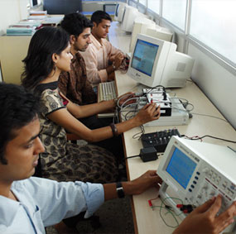
Industrial connection
Software Engineering program interacts and liaises with well-reputed industries to facilitate funded projects, research and consultancy in the chosen areas. The Program Corporate Advisory Board includes top executives from leading Software Industries such as Amazon, Pyoda, Aricent, McAfee, Capital IQ, NTT data, Ascendas, etc. Industrial partnership with Clockworks Interview was created as MOU.

SCOPE OF THE CONFERENCE

This conference is to provide an international forum for industry professionals and researchers to deliberate and state their research findings, discuss the latest advancements and explore the future directions in the emerging areas of Engineering and Technology.
The conference also bring together both novice and experienced scientists and developers, to meet new colleagues, collect new ideas and establish new cooperation between research groups and provide a platform for researchers from academic and industry to present their original work and exchange ideas, information, techniques and applications in the field of Software Engineering, networking, Big Data, Cloud Computing, Data Analytics, IOT and other blooming areas of research.

The selected original papers presented in the conference will be published in Springer series “Advances in Intelligent Systems and Computing” (AISC) [Pending Approval]

Call for Papers

Original Contributions are solicited on topics covered under broad areas such as (but not limited to):
- Artificial intelligence
- Software Engineering
- Big data Analytics
- Computer Networks
- Scientific Computing
- Wireless Sensor Networks
- Cloud Computing
- Grid Computing
- Expert Systems
- Digital Image Processing
- Watermarking
- Information Retrieval
- Mobile Computing
- Multimedia Applications
- Security & Cryptography
- Software Engineering & CASE
- Soft Computing Applications in Power Systems
- Optimization in Power System Modeling & Control
- Power System Stability and Switchgear and Protection
- Power Quality Issues and Solutions
- Smart Grid
- Diagnosis and sensing systems
- Pattern recognition
- VLSI/Embedded Systems
- Nano Technology and MEMS
- Nanoelectronics/Devices
- Photonic/Opto-Electronic Structures/Devices
- Digital Communication and Telecommunication
- Microprocessor based Technologies.
- Networking
- Grid and Cloud Computing
- DNA and Mobile Computing
- High throughput Computing
- Data Structures & Algorithms
- Artificial Intelligence and Expert Systems
- Automated Software Engineering
- Bioinformatics and Scientific Computing
- Computer Architecture and Embedded Systems
- Computer Graphics & Virtual Reality
- Computer Networks & Security& Cryptography
- Computer-aided Design/Manufacturing
- Data Compression, Data Encryption, Data Mining
- Image Processing
- Distributed Systems
IMPORTANT DATES
Paper submission : January 10th, 2019
Acceptance Notification : February 22th, 2019
Registration and camera ready : March 10th, 2019

PARTICIPATION & DELEGATE FEES

Indian Delegates
Researcher / Student INR 7500/-
Academic INR 8000/-
Industrial INR 8500/-
Foreign Delegates US $300
Foreign Students US $250

Chief Patron
Dr. T. R. Paari Vendhar, Chancellor, SRMIST, India.
Mr. Ravi Pachamoothoo, Chairman, SRM Group, India.
Mr. P. Sathyanarayanan, President, SRMIST, India.
Dr. R. Shivakumar, Vice President, SRMIST, India.

Patrons
Dr. Sandeep Sancheti, Vice Chancellor, SRMIST, India.
Dr. T. P. Ganesan, Pro-Vice Chancellor, SRMIST, India.
Dr. C. Muthamizhchelvan, Director (E&T), SRMIST, Chennai, India

General Chair:
Dr Bijay Ketan Panigrahi, IIT Delhi
Dr. Subhransu Sekhar Dash,GCE,Keonjhar, India
Dr. Swagatam Das, ISI Kolkatta

General Co-Chair:
Dr. P.N. Suganthan, NUS, Singapore
Dr. AA Jimo, TUT, South Africa

Organizing Chair:
Dr. C. Lakshmi, SRMIST, Chennai, India
Mr. V. Sivakumar, SRMIST, Chennai, India

Organizing Co-Chair
Mr. S. Karthik, SRMIST, Chennai, India
Mr. G. Senthil kumar, SRMIST, Chennai, India
Mrs. T. S. Shiny angel, SRMIST, Chennai, India

Program Chair:
Dr. C. Lakshmi, SRMIST, Chennai, India
Dr. Subhransu Sekhar Dash,GCE,Keonjhar, India

Program Co-Chair:
Dr. Ilhami colak , Gazi University, Turkey.
Dr. Ramazan Bayindir, Gazi University, Turkey
Dr. J.S. Femilda Josephin, SRMIST, Chennai, India

Special Session Chair:
Dr. S.Paramasivam, Danfoss, Chennai
Dr. Ahamed Zobaa, UK
Dr. P.N. Suganthan, NUS, Singapore
Dr. Florian Misoc, UWM, USA

Publicity Chair:
Mrs. S. Krishnaveni, SRMIST, Chennai, India
Mrs. C.G.Anupama, SRMIST, Chennai, India

Publication Chair:
Dr. G. Usha, SRMIST, Chennai, India
Dr. M. Ferni Ukrit , SRMIST, Chennai, India

Public Relation Chair:
Dr. Sridhar Krishnaswamy, SRMIST, Chennai, India
Mr. V. Haribaabu, SRMIST, Chennai, India

Finance Chair:
Ms. Sasi Rekha Sankar, SRMIST, Chennai, India
Mr. S. Selva kumara samy, SRMIST, Chennai, India

Organizing Committee
Mrs. M. Uma, SRMIST, Chennai, India
Mrs. M. S. Abirami, SRMIST, Chennai, India
Mr. K.Vijayakumar, SRMIST, Chennai, India
Mrs. D. Anitha, SRMIST, Chennai, India
Mrs. S. Aruna sankaralingam, SRMIST, Chennai, India
Mrs. J. Jeyasudha, SRMIST, Chennai, India
Mrs. S. Amudha, SRMIST, Chennai, India
Mrs. B. Jothi, SRMIST, Chennai, India
Mr. C. Arun , SRMIST, Chennai, India.
International/ National Advisory Committee
Dr. D. Narayanan Rao, Director (Research), SRMIST, Chennai
Dr. V. Kashmir Raja Dean (Research), SRMIST, Chennai
Dr. B. Amutha, SRMIST,Chennai
Dr. S. S. Sridhar, SRMIST, Chennai
Dr. C. Malathy, SRMIST, Chennai
Dr. E. Poovammal, SRMIST, Chennai
Dr. G. Vadivu, SRMIST, Chennai
Dr. S. Rajendran, SRMIST, Chennai
Dr. R. Subburaj, SRMIST, Chennai
Dr. V. Ganapathy, SSRMIST, Chennai
Dr. Akhtar Kalam, VU, Australia
Dr. Alfredo Vaccaro, US, Italy
Dr. David YU, UWM, US
Dr. A. Kannan, AU, Chennai
Dr. Dmitri Vinnikov, TUT, Estonia
Dr. Paul Rodriues, KKU, Saudi Arabia
Dr. V. Vijayakumar, VIT Chennai
Dr. S. Bose, AU, Guindy , Chennai
Dr. P. Vijayakumar, UCE, Tindivanam
Dr. A. Karthiga VISTAS, Pallavaram
Dr. R. Anandan, VISTAS, Pallavaram
Dr. Gorazd Štumberger, UM, Slovenia
Dr. Hussain Shareef, UKM, Malaysia
Dr. K. Selvamani, AU, Guindy, Chennai
Dr. A. Bharathi, BAIT, Erode
Dr. Jagan, SEG, Villupuram
Dr. Vijayarajan, VIT, Vellore
Dr.S. Balachandran,IMT,Chennai
Dr. A. Umamageswari, DMI, Chennai
Dr. Dan M Ionel,UKCE,Kentucky
Dr. Mohamed A. Zohdy, OU, MI
Dr. Murad Al-Shibli, Head, EMET, Abu Dhabi
Dr. Nesimi Ertugrul, UA, Australia
Dr. Omar Abdel-Baqi, UWM, USA
Dr. Adel Nasiri, UWM, US
Dr. Richard Blanchard, LBU, UK
Dr. Shashi Paul, DM, UK
Dr. AA Jimo, TUT, South Africa
Dr. Zhao Xu, HKPU, Hong kong
Dr. Mohammad lutfi othman , Universiti Putra Malaysia,
Dr. Vivekananda Mukherjee, Indian School of Mines, Dhanbad .
Dr. S.Jeevananthan, PEC,,Puducherry , India
Dr. Debashish Jena, NITK, India.
Dr. M. P Somasundaram, Anna university, Chennai, India
Dr. N.K. Mohanty, SVCE, Chennai
Dr. Sidhartha Panda, UCE, Burla,
Dr. K Vijayakumar,SRMIST, Kattankulathur
Dr. Suresh Chandra Satapathy,ANITS, Vishakapatnam
Dr. N Senthil kumar, MEPCO, TN
Dr. N.P. Padhy, IIT Roorkee
Dr. Patnaik S.K, Anna University
Dr. Rama Reddy S, JCE
Dr. G. Uma, Anna University
Dr. K.Shanti Swarup, IIT-Madras
Dr. R K Behera, IIT Patna
Dr. R K Sahoo, UCE, Burla
Dr. B K Nandha, SOA, Orissa
Dr. P K Dash, SOA, Orissa
Dr. A K Pradhan, IIT Kharagpur
Dr. Bijay Ketan Panigrahi, IIT Delhi

How to Reach SRMIST
SRMIST Main Campus (Kattankulathur) is well connected by road, rail and air. It is 40 km from Chennai city in NH 45 and around 20 km from Chennai Airport. The nearest Bus stop and the nearest Railway station for the university is POTHERI.

By Train and Bus:
People who come from other states by train, after getting down at Chennai Central Station, should come out of the station, cross the High road through the pedestrian subway to reach PARK suburban metro rail station. Two destination trains are available from Park suburban metro rail station to (i) Tambaram (ii) Chengalpattu. If you take the train to Tambaram, then get down at Tambaram, come out of the station to reach the local bus stand. Take M500,M118,T60 or T60 LSS and demand ticket from the conductor for SRM or Potheri. It may take nearly 20 minutes travel from Tambaram to reach SRMIST. (Total Travel time from Chennai Central Railway Station will be around One Hour). If you take the train to Chengalpattu, you can directly get down at SRM or Potheri railway station. SRMIST is just opposite to the Potheri railway station.

By Air:
The nearest railway station is located just opposite to the Chennai Airport. The name of the Railway Station is Thrisulam. Catch a train towards Tambaram and follow the instructions given above for reaching SRMIST.

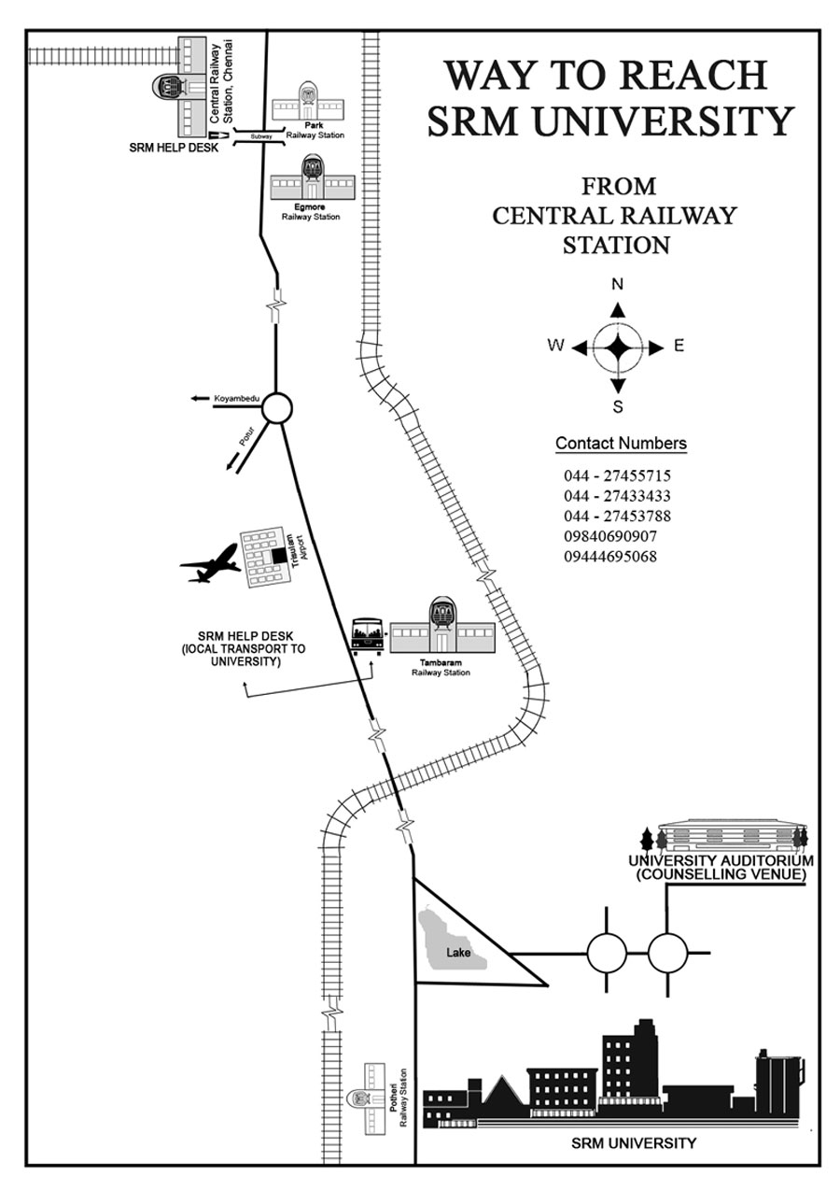

International Conference on Artificial Intelligence and Evolutionary Computations in Engineering Systems

ICAIECES-2019

April 11th - 13 th, 2019

Registration Form

Name : Prof./Dr./Mr./Ms............................................

Gender : Male / Female

Designation : ...................................................................

Dept. / Organisation : ...................................................................

(With postal address) : ...................................................................

Accommodation : Yes No

E-mail : ...................................................................
Phone : (R) (O)
Mobile :

Author : Yes No

Paper Title & No : ...................................................................

Registration Fee : ...................................................................

Demand Draft details : No: Bank: Dated:

Place
Date

Signature of the Candidate

Seal & Signature of the Sponsoring Authority

